.4Nn&v
How to sort your waste
iii

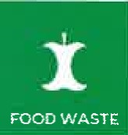
FOOD WASTE
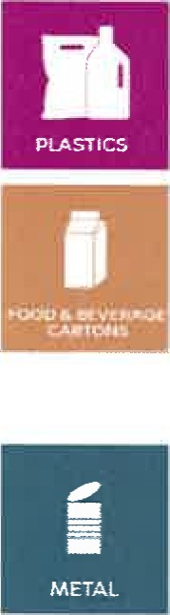
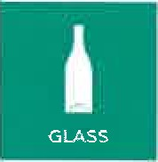
Food waste is converted into biogas and fertiliser.
Food waste - raw as well as cooked - meat, fish, bones, fruits and vegetables, eggs and eggshells, nuts, rice, breakfast products, coffee grounds and filters, cut flowers. Use only bio bags and always tie with a knot.
Glass and jars are refilled or turned into new jars.
Wine and liquor bottles, food jars etc. Empty food jars and bottles as well as you can - the lid can stay on.
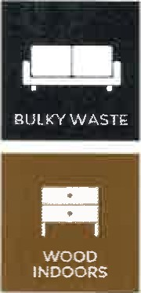
Paper is recycled into new products. Newsprint and magazines, advertising materials, envelopes, also window envelopes, books, writing- and drawing paper. No need to remove clips or tape.
Cardboard is recycled into new products. Cardboard boxes without styrofoam, corrugated board/ cartons, packaging for toys, toothpaste etc.
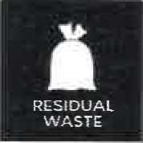
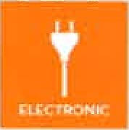
Cardboard and cartons must be clean and folded flat before drop-off.
Electronic waste. Small household devices are recycled into new products.
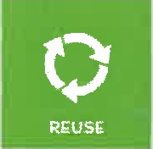
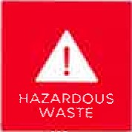
Anything with batteries or wires. Phones and chargers, electric toothbrushes, electric toys, irons, small kitchen utensils such as hand mixers, blenders etc., postcards, shoes and ties with light or music. Lithium batteries must be taken to recycling centre.
Hazardous waste. For treatment under controlled conditions.
Chemicals and poisons, low-energy light bulbs, fluorescent tubes, paints, spray cans and larger batteries - Lithium batteries must be taken to recycling centre. Products and empty containers marked with hazard pictograms are hazardous wastes.
Soft and rigid plastics and cartons from food and beverages are recycled into new products.
Plastic bottles without refund, bottles used for beverages and shampoo, trays from fruit and ice cream, plastic bags, plastic wrap. Milk and juice cartons. Empty packings and cartons as well as you can.
Metal is recycled into new products. Containers of metal without refund, tins and cans, pots and pans, utensils and foil, nails and screws, tools, metal boxes. Empty all containers as well as you can.
Bulky waste. Most items are turned into electricity and heat.
Furniture, mattresses, carpets, metal, window glass, building waste from DIY work. Wood - e.g. furniture and other indoor wood - must be placed separately to be recycled. Bricks, tiles, concrete and similar, sanitary equipment, roofing slates, soil/stone/gravel must be taken to the recycling centre.
Residual waste are converted into electricity and district heating. Pizza boxes and other greasy cardboard and paper, diapers, hygiene waste, styrofoam, animal litter, vacuum bags, barbecue ash and other dusty waste. All residual waste must be properly placed in closed bags.
Freecycle. Give what you have - take what you can use.
Books, clothing, cookware, toys, knickknacks, DVDs and electronic appliances that work..

You can find more information on how to sort your waste on kk.dk/affald

